Model Architecture and Design Decisions

Model is a fully connected neural network (also called a deep feedforward network).

Below is a simple breakdown of the design choices:

1. Input Layer

input_dim=X_scaled.shape[1]: The model takes features from X_scaled.

Reason: Since data is transformed using PCA, it has fewer features.

2. Hidden Layers

First Layer: Dense(256) → 256 neurons + ReLU() activation.

Second Layer: Dense(128) → 128 neurons + ReLU() activation.

Third Layer: Dense(64) → 64 neurons + ReLU() activation.

Reason:

- More neurons in the first layers help capture complex patterns.

- ReLU activation prevents the vanishing gradient problem.

- Dropout (0.3) reduces overfitting by randomly turning off 30% of neurons.

3. Output Layer

Dense(1, activation='linear')

Reason: Since this is a regression task, we use linear activation to get continuous values.

Design Choices:

1. Feature Scaling

StandardScaler() is used for both X and y.

Reason:

- Neural networks work better when data is standardized.

- Scaling y ensures the model does not struggle with large values.

2. Optimizer and Loss Function

Optimizer: Adam(learning_rate=0.001)

Loss Function: mean_squared_error (MSE)

Reason:

- Adam is efficient and adapts the learning rate dynamically.

- MSE is commonly used for regression tasks.

3. Regularization & Early Stopping

Dropout(0.3): Reduces overfitting.

EarlyStopping(monitor='val_loss', patience=20): Stops training when validation loss stops improving for 20 epochs.

4. Evaluation

Metrics: Mean Absolute Error (MAE), R² Score.

Reason:

- MAE helps measure average prediction error.

- R² Score shows how well the model fits the data (closer to 1 is better).

Training Process:

Steps in Training
- Data Preprocessing
  - Input features (X_pca_optimal) and target values (y) are scaled using StandardScaler().
- Model Initialization
  - A fully connected neural network is created with multiple hidden layers and ReLU activation.
- Compilation
  - Optimizer: Adam(learning_rate=0.001)
  - Loss Function: Mean Squared Error (MSE)
  - Metric: Mean Absolute Error (MAE)
- Early Stopping
  - Monitors validation loss and stops training if it doesn’t improve for 20 epochs.
- Training Execution
  - Uses 350 epochs and batch size of 32.
  - 80% data for training, 20% for validation.
- Model Evaluation
  - Computes loss and MAE on test data.

Loss Curves:

Why Plot Loss Curves?
- Helps check if the model overfits or underfits.
- Shows whether the model is improving over epochs.
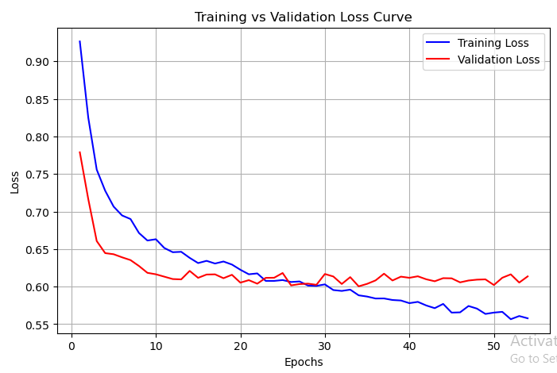

Evaluation Metrics:

Metrics: Mean Absolute Error (MAE), R² Score.

Reason:

- MAE helps measure average prediction error.

- R² Score shows how well the model fits the data (closer to 1 is better).

